Fundraising Activities
- Movie night

  - Use a projector at the school gym

  - 3$ admission fee (students can set the price)

  - Movie must be age appropriate

  - There can be two movies in one night for two age groups, for example;
    - 7pm to 9pm children ages 1-14 (or 17 depending on the movie) with children under 6 years old must be accompanied by a parent/guardian
    - 9pm to 11pm teenager/adults ages 15 and up

  - Canteen: popcorn, candy, pop, juice and other snacks. Buy from Staples/Bureau en Gros (https://www.staples.ca ), they have free shipping and cost a fraction of the price compared to coop/northern. If you need to buy from coop/northern always request for a discount.
    - Make sure to announce on the local FM radio station that there is a canteen available to the public (some communities don’t have a corner store, so, you can get customers that are not going to watch the movie)

  - Bake sale goods

  - Advertise on Facebook, local FM radio and put up posters around town
    - Use Canva a free poster/logo web design page for all the poster ads https://www.canva.com (page 151 of the student workbook).

- Make request letter to local organizations for donations/financial support/discount
  - Create a request letter with your students, you can use the template on the appendix

  - List of local organizations

    - Northern Village of … (Municipality-request to municipal council via Secretary-Treasurer)
      - Most NVs put aside money for community projects initiated by local residents

    - Hunter Support Program (request to municipal councillor via Secretary-Treasurer)
      - HSP cannot provide financial support, but they have hunting equipment and warm clothes for camping
      - Make a request for donation/discount of hunting supplies or clothing for a raffle draw

    - Local Kativik Regional Government (KRG) representative (member of the municipal council)
      - Financial contribution for community project

    - Local Makivik representative
      - Financial contribution for community project
      - Air Inuit Ticket for raffle draw

    - Local co-op board of directors
      - Financial contribution for community project
      - Discount on purchase for student project
      - Donation of food or items

    - Local Northern store
      - Financial contribution for community project
      - Discount on purchase for student project
      - Donation of food or items

    - Culture Committee
      - Financial contribution for culture project
      - Resources: Elders, cultural artifacts, cultural activities, etc.

    - Landholding Corporation
      - Financial contribution for community project

- Dance/disco or just dance game night

  - 3$ admission fee (students can set the price)

  - Canteen: popcorn, candies, pop, juice and other snacks. Buy from Staples/Bureau en Gros, they have free shipping and cost fraction of the price compared to coop/northern. If you need to buy from coop/northern always request for a discount.

  - Bake sale goods

  - Advertise on Facebook, local FM radio and put up posters around town.
    - Use Canva a free poster/logo web design page for all the poster ads https://www.canva.com (page 151 of the student workbook).
    - Here is an example of FB advertisement from the Youth Committee in Kangirsuk

- Canteen during recess

  - Bake sale goods

  - Healthy snacks banana, yogurt, fruit cups, etc. (buy from Marché Daoust because they will have nutrition north subsidy)

- Takeout/delivery meals

  - Teach students how to cook healthy meals

  - Sell them as takeout or delivery

  - Advertise on Facebook, local FM radio and put up posters around town
    - Use Canva a free poster/logo web design page for all the poster ads https://www.canva.com (page 151 of the student workbook).
  - Here is an example of Pre-Work student’s fundraiser advertisement in Kangirsuk.
  - 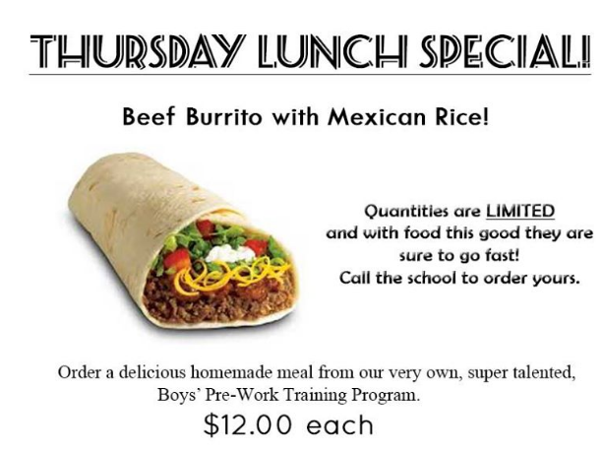

- Provide services:

  - Cleaning-mopping-dishes

  - Babysitting

- Different types of draws/raffles:

  - Straight Up Raffle:
    - Find great prizes, or the students can make anything from ski-doo sled, uluk, hunting equipment, kamik, sealskin purse with beading, parka, etc. that will be used as the prize

    - Use raffle tickets and set price and offer deals

    - Decide on a date and place (during BINGO night or Facebook live) for the draw (if the raffle is not for a specific event)

    - First ticket pulled out is the winner

    - Create some exposure and excitement about the raffle by promoting it through Facebook, posters and FM radio

  - Elimination draw (reverse raffle)

    - Find great prizes, or the students can make anything from ski-doo sled, uluk, hunting equipment, kamik, sealskin purse with beading, parka, etc. that will be used as the prize.

    - Decide on a date and place (during BINGO night or Facebook live for the drawing (if the raffle is not for a specific event)

    - Create some exposure and excitement about the raffle by promoting it through Facebook, posters and FM radio

    - Elimination draw is reverse raffle, last number wins the prize

    - You can set a limited about of tickets: example, 1 ticket =10$ and there are 100 tickets, once all tickets are paid then you can start the elimination draw

    - Example of FB advertisement:

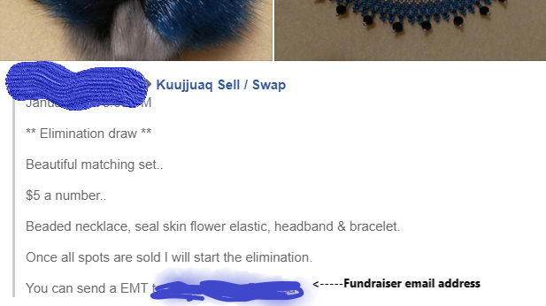

  - 50/50 raffle

    - Use raffle tickets and set price, you can also do deals
      - For example: set the price for 1 ticket = $5, and have deals if let’s say customer buys 5 tickets = $20 (giving 1free ticket for each 5 tickets)

    - Same rules as straight up raffle

  - Air Inuit/First Air plane ticket draw

    - Make a request letter to the local Makivik representative
      - The project details and explanation of what the money will be used for should be included in the letter
    - Once you have the plane ticket (if your request was approved), you can do a regular raffle draw or elimination draw

    - Same rules as straight up raffle

- BIZARRE – similar to a garage sale but inside the school gym

  - Advertise the bizarre well in advance 2-3 weeks

  - Set a price for tables/space, 10-15$ is a fair amount to charge

  - Have an auction of student crafts -from culture class (sewed articles, hunting equipment, sled for kids, etc.)

  - Students can bake sale and/or prepare take-out food

  - Do raffle draw

- Ask parents to participate

  - If one of the students has a parent that is known to make baked goodies, warm clothing (seamstress), sled/ulu (carpenter), carving (carver), etc. you can ask the student’s parents to pitch in and donate one of their crafts to raise money for their project

- Collect pop cans

  - Ask students to start collecting pop cans at home or at school

  - Put out posters requesting for pop cans go be donated and dropped off at a specific location

  - Make an announcement on Facebook and local FM radio
- Discount on purchases at local store(s)

  - Local stores normally give 10% discount for student projects/fundraisers

  - Make sure to always ask if you can get a discount, and explain the project/fundraiser to the store manager

