Name:________________________
Snow Density Protocol

*** Adapt this document to your students’ level ***

- Measure the dimensions of the sampling instrument and determine the volume. For more precision, measure the inside of the instrument.

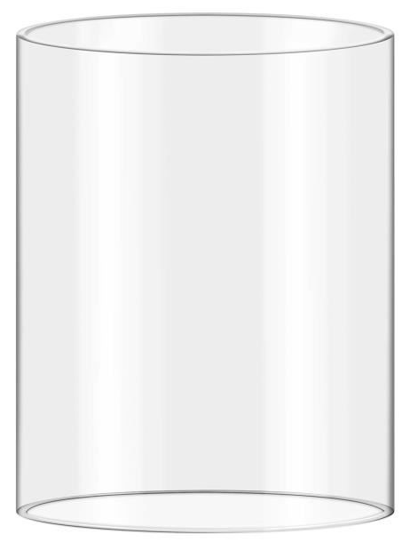

Diameter:_________ cm.

Radius: (Diameter ÷ 2) = _________ cm.

Height:_________ cm.

Volume: (πr² x h) = _________ cm³.

The inside volume of the sampling instrument is ____________ cm³.

- Weight the empty sampling instrument and note the weight.

The weight of the empty instrument is ____________ g.

- Take a snow sample by pushing the tube into snow and pulling it out.

- Weight the full sampling instrument and note the weight.

The weight of the full instrument is ____________ g.

- Calculate the net weight of the sample.

____________________ - ______________________ = _________
Weight of the full instrument Weight of the empty instrument Net weight

- Use the formula to calculate the snow sample’s density.

____________________ ÷ ______________________ = _________
Net weight of the sample Volume of the instrument Density (ρ)

- Repeat steps 3 to 6 for each type of snow and note the results in a table.

 | Aqilluqaq | Sitilluqaq | Pukajaq
Sample and instrument weight
Sample net weight
Sample density

